

Bangabandhu Sheikh Mujibur Rahman Science & Technology University

Gopalganj-8100.

**Project Papers**

**Snake & Ladder Game**

Submitted by

Md. Mizanur Rahman

ID- 20131201035

Submitted to

**Saleh ahmed**

Associate professor

Dept. of CSE

BSMRSTU

**Snake & Ladder Game**

(Using C language with graphics)

Submitted by

Md. Mizanur Rahman

ID: 20131201035

Department of Computer Science & Engineering

BSMRSTU

Course Title : Project

Course Code : CSE 168

Submitted to

**Saleh Ahmed**

Associate professor

Department of Computer Science & Engineering

BSMRSTU

…………………………………..

Signature of supervisor

**Index**

**Chapter Page No.**

1. Abstract. 04
2. Introduction. 05
3. Related Work. 06
4. Implementation Details. 07
5. User Manual. 09
6. Limitation & Future Work. 12
7. Discussion. 13

**Abstract:**

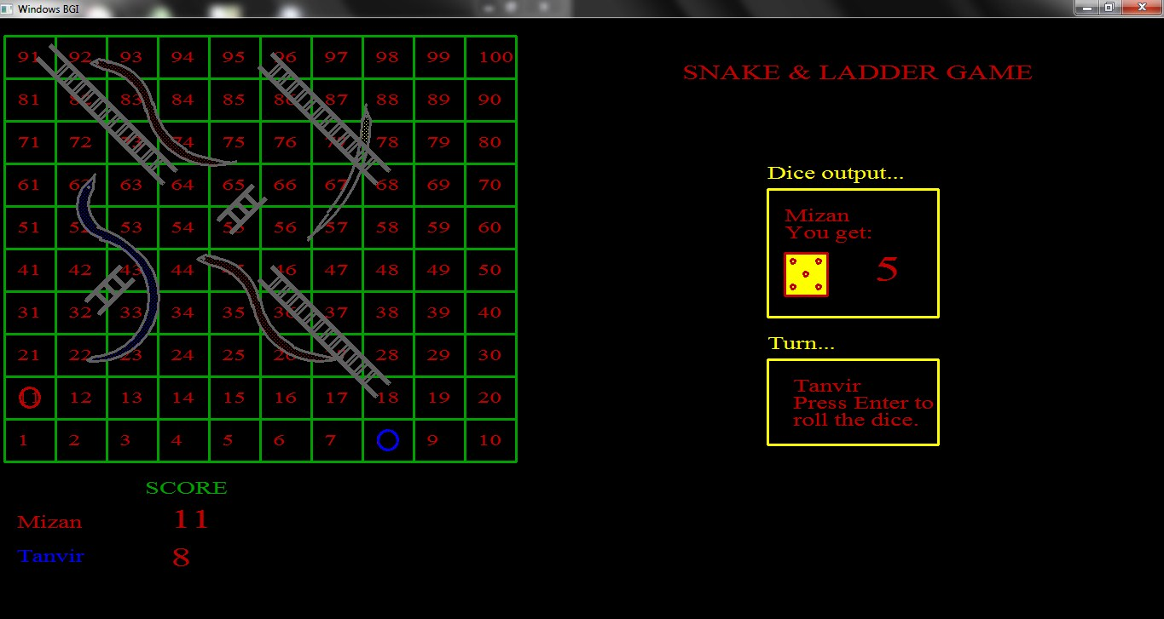

A game is a source of entertainment. A game gives us pleasure. Like other games my “Snake & Ladder Game” also gives us entertainment and pleasure.

In this game beside logic graphics is also an important part. Logic can make the game efficient but graphics increase the beauty of the game. And this beauty attract people to play the game.

In this project I used simple logic and primary steps of graphics. In case of my first project there are many lacings in this “Snake & Ladder Game”. But as a newcomer in graphics world I try my best to make the game attractive.

Considering all, I think users will like this game and be happy.

**Introduction:**

Generally, Snake & Ladder Game is a game which is played with board and dice. But I try to make this different. That’s why I started to make this game. I use C language to make the game. I have to use graphics in this game.

In this game, player has to just press any key to roll the dice. That is very easy task for the player. Some snake and ladder has to use in this game. Those are totally made of graphics.

This game has some limitation. I will be try to overcome this limitation in recent future. I will be try to make this game better in next version.

**Related Work:**

It is a simple game project. It is made only for entertainment. So, this game has not other related work.

But it is only my first project. Next time I will try to make more efficient software.

I hope the next versions of this game will be contains some related work.

**Implementation Details:**

Here you will be able to know about the implementation process of this game.

In my code, I use some user define function. Which make my task easier. This user define functions will help me to develop the game next time.

My user define functions are:

int welcome();

int board();

int ladder1();

int ladder2();

int snake1();

int snake2();

int snake3();

int numbering();

int random();

int status();

int dispdice(int dice);

int guti1(int num);

int guti2(int num);

int clrguti(int num);

int play();

**Welcome:** To welcome the player in “Snake & Ladder Game”.

**Board**: This function will display the board.

**Ladder:** The ladder1 and ladder2 has used to make the ladders.

**Snake:** The snake1, snake2 and snake3 functions are used to display the snakes.

**Numbering:** Numbering function is used to identify the number of blocks and show their number.

**Random:** Random function is used for generate a random number for the dice.

**Status:** Status function has made the scoreboard and the board for display the dice output and turn box which is display the player’s name who will be roll the dice.

**Dispdice:** Dispdice function will display the dice which will contain the number player got from the dice.

**Guti1:** Guti1 function is used for mark the player 1’s position in board.

**Guti2:** Guti2 function mark the player 2’s position.

**Clrguti:** Clrguti function clear the previously marked position.

**Play:** Play function define the procedure of playing the game.

**User Manual:**

Here player can learn the process of controlling the game.

“Snake & Ladder Game” is an easy game to play. First a welcome screen will be appear. When “Snake & Ladder Game” board will appear, then you have to enter the players name on the .exe file, which is located behind the game screen. Then the turn box in game screen will notified the player to roll the dice by pressing any key. Then the dice output box will show the dice and the number which you got by rolling the dice.

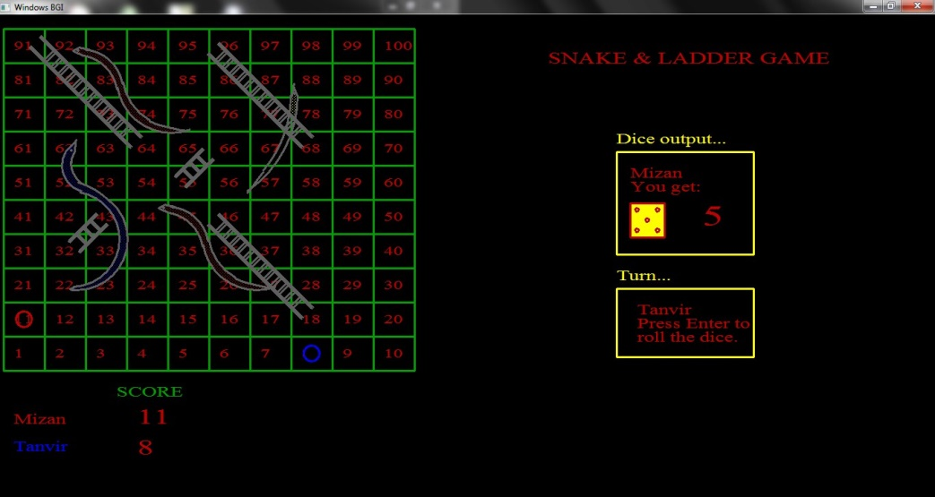

The score of players will be displayed in the lower part of the game screen.

If you get a ladder then it will display a line containing “Congratulation!!! You get a ladder.” Beside your name in score card.

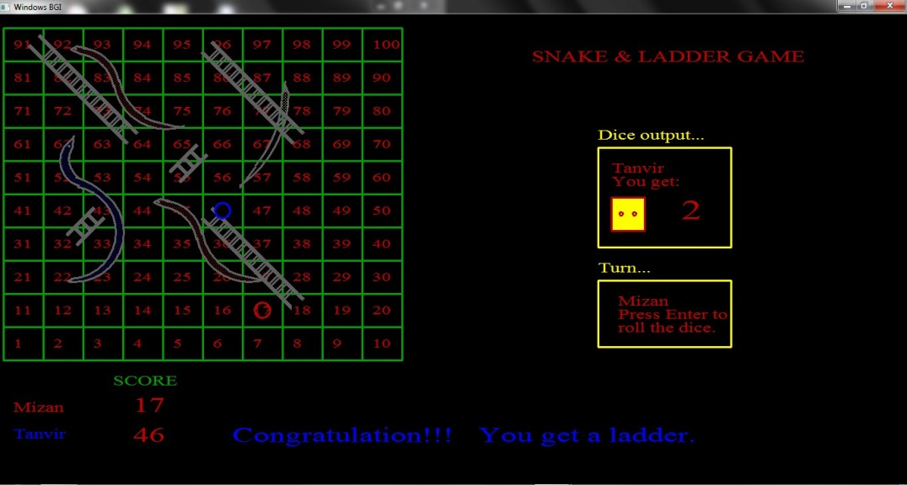

If you bitten by snake then a massage will be displayed containing “Bad luck!!! You are bitten by snake”.

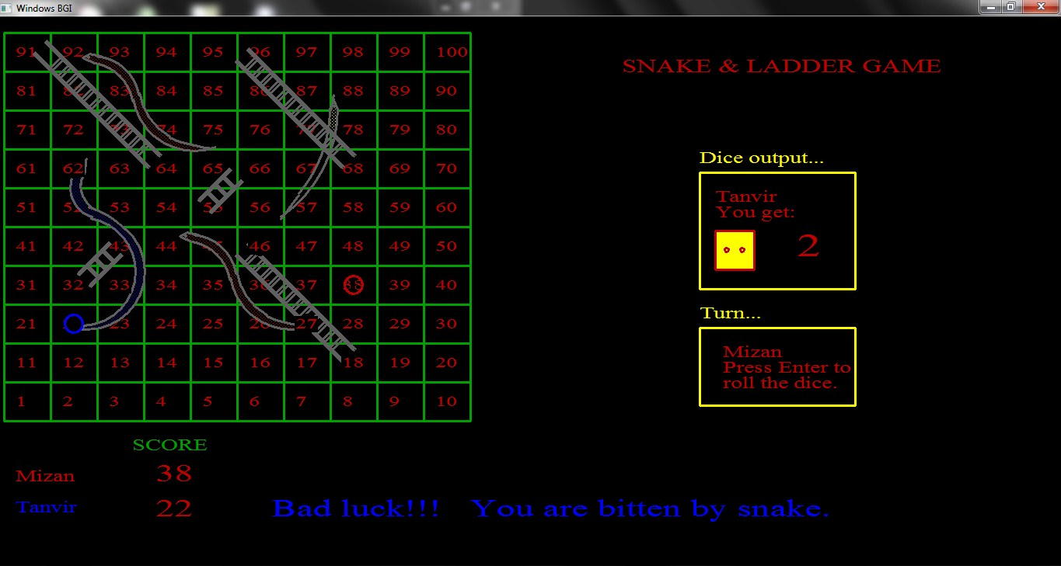

If your score be greater than 100 then, “You cross the limit.” Massage will be shown beside your name.

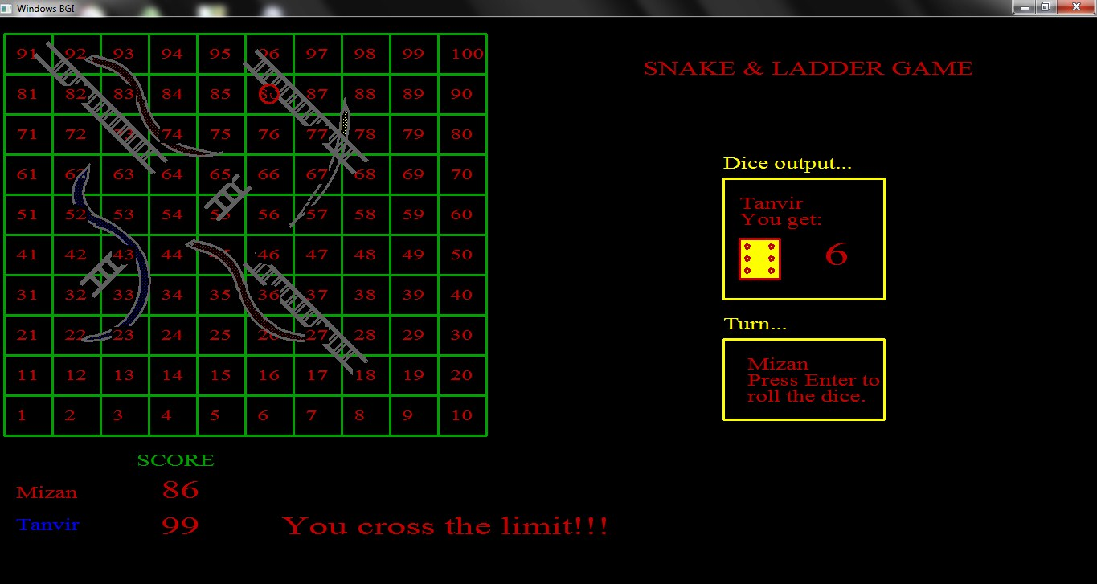

Your position will be marked with a red or blue circle by matching with your name color which is in the score card.

If you win then a massage will be printed on the screen containing

“Congratulation!!!

(Your name), You Win.”

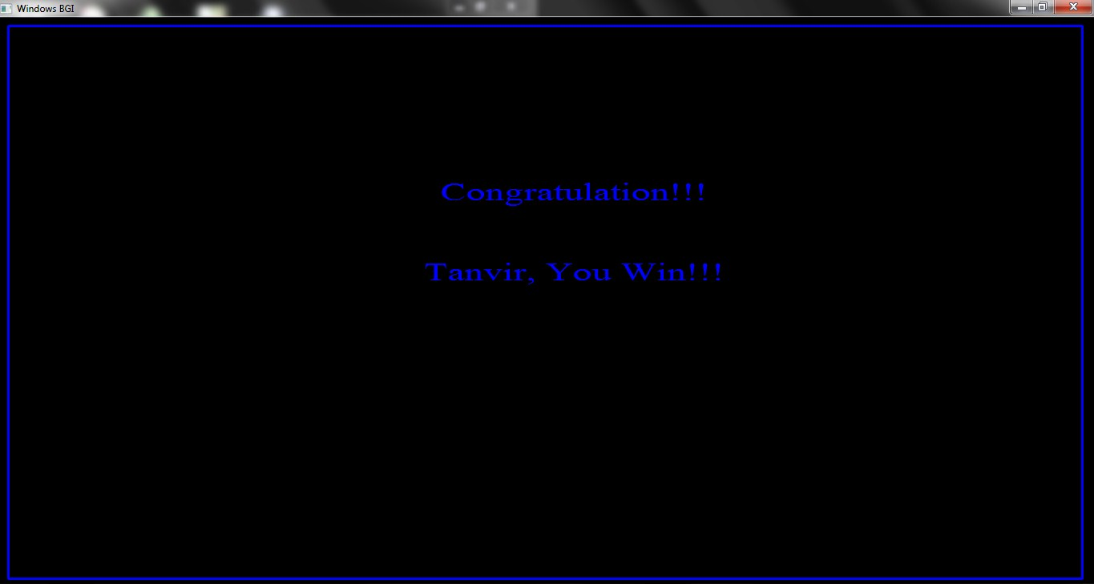

**Limitation & Future Work:**

As it is my first project there are some limitations in my project.

Limitations like:

* It does not show the rolling of dice.
* Snakes are not looking so good to see.

In Future I want to add some other facilities in this project, like

* It will show the rolling the dice.
* Graphics will be developed.
* I want to add ludu game with this project.

**Discussion:**

C is a suitable language for newcomer in programming world. To build a game we have to work hard with different types of logic. It increases our thinking power. Beside logic it helps us to present ourselves to the users.

A game project increases our attraction to the programming. So that, programming will be a game or fun to us. We will be interested in programming very much, which is a very usefull side for us.

Besides, it will attract the newcomers in programming world. They will be encouraged, which is a positive sign for us.

**Thanks all.**